# **Using BAMS**

**The BarnCamp Attendee Management System**

BAMS is a classic console application that strives to use the keyboard to do things as much as possible. To this end a set of different function and other control keys on a standard PC or Macintosh keyboard has been chosen to help you navigate the program. We have striven to make the same key do the same kind of thing on every screen where it's used. The operations of the keys are as follows:

* F1 - Return to the BAMS Home Screen (available on all screens except from the Home Screen itself).
* F2 - List all attendees in the system and choose one to edit.
* F3 - Add a new attendee to the system.
* F4 - Search for by AuthCode, Name or Email, and then Edit a given attendee already in the system.
* F5 - Screen specific function. On Edit toggles the arrival day. On Search searches by AuthCode.
* F6 - Screen specific function. On Edit toggles the attendance status. On Search searches by Name.
* F7 - Screen specific function. On Edit toggles the payment status. On Search searches by Email.
* F8 - Save changes to the current attendee being edited.
* F9 - Toggle the screen colours between monochrome and colour (default is colour).
* F10 - Exit BAMS from the Home Screen and return to the operating system.
* PgUp/PgDown - Scroll screen-by-screen through a list of attendees.
* ENTER - Tell BAMS to display the Edit Screen for the record number entered on the List Screen.

All other keys should more or less work as one might expect.

## **Home Screen**

The home screen looks like this:

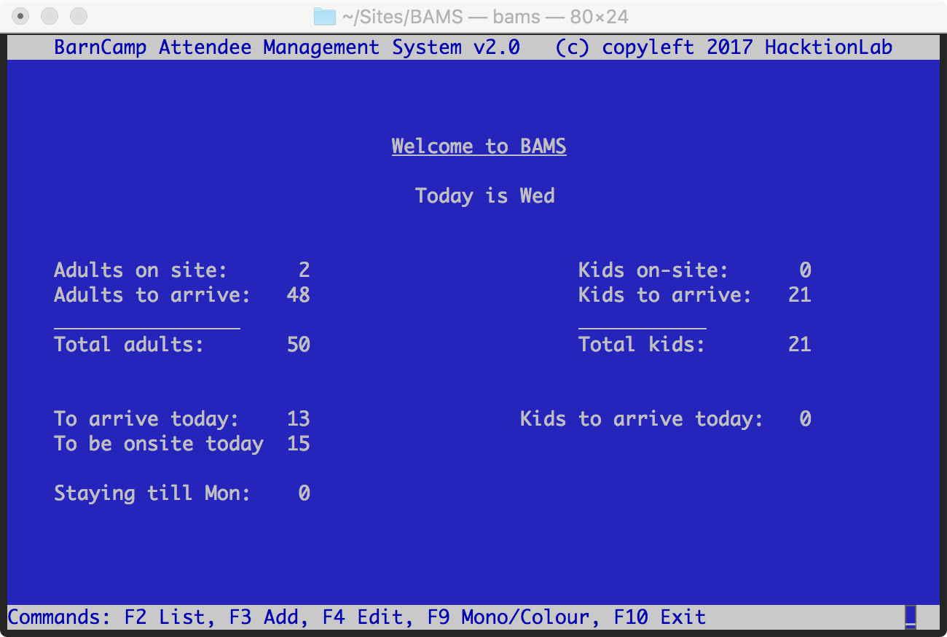

In the middle you can see what the day is, and you can immediately tell how many adults and children are attending and how many are on-site already, and are to arrive. There are three function key options:

* F2 - List all attendees, and choose one to Edit.
* F3 - Add a new attendee, which takes you to the Add Attendee Screen.
* F3 - Edit an attendee, which takes you firstly to the Search Screen.
* F9 - Toggle the screen colours between monochrome and colour.
* F10 - Exit BAMS and return to the operating system.

## **Search Screen**

Pressing F4 from the Home Screen will take you to the Search Screen, which looks like this: [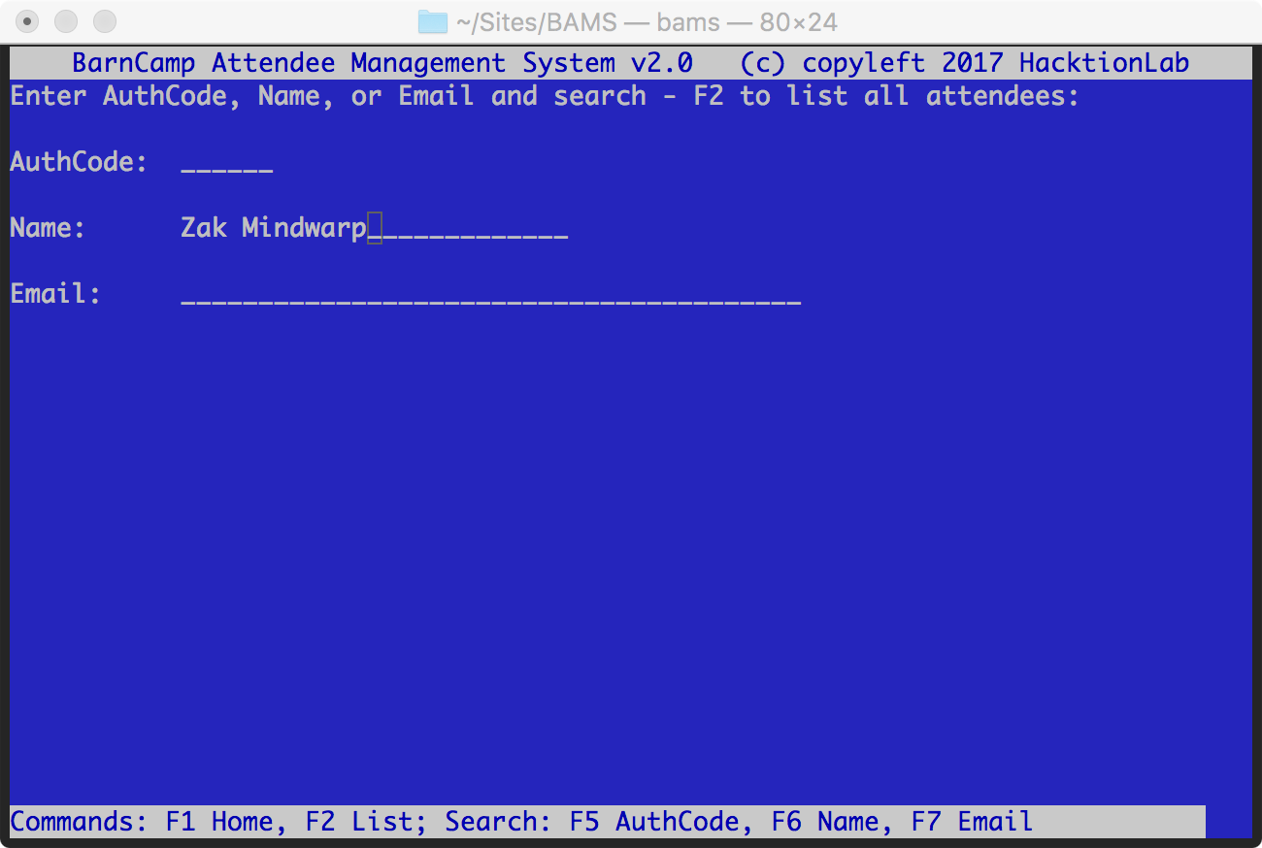](https://github.com/thebrentc/BAMS/blob/master/screenshots/enter-authcode-screen.png)

[You have three options:](https://github.com/thebrentc/BAMS/blob/master/screenshots/enter-authcode-screen.png)

* Enter the AuthCode and press F5 to search by authcode.
* Enter the Name and press F6 to search by name.
* Enter the Email and press F7 to search by email.
* F1 - go back to the Home Screen
* F2 - Rather than enter the Authcode, go to the List Attendees Screen to locate the attendee you want.

When entering the AuthCode, Name or Email note that the match is case-insensitive, but it is an exact string match. Therefore "Mike" will not locate "Mike Harris". In addition if there are multiple records with the same data in the search field, the first record encountered is returned.

## **List Attendees Screen**

This screen shows a list of all attendees and allows you to page through them and then choose one to view. [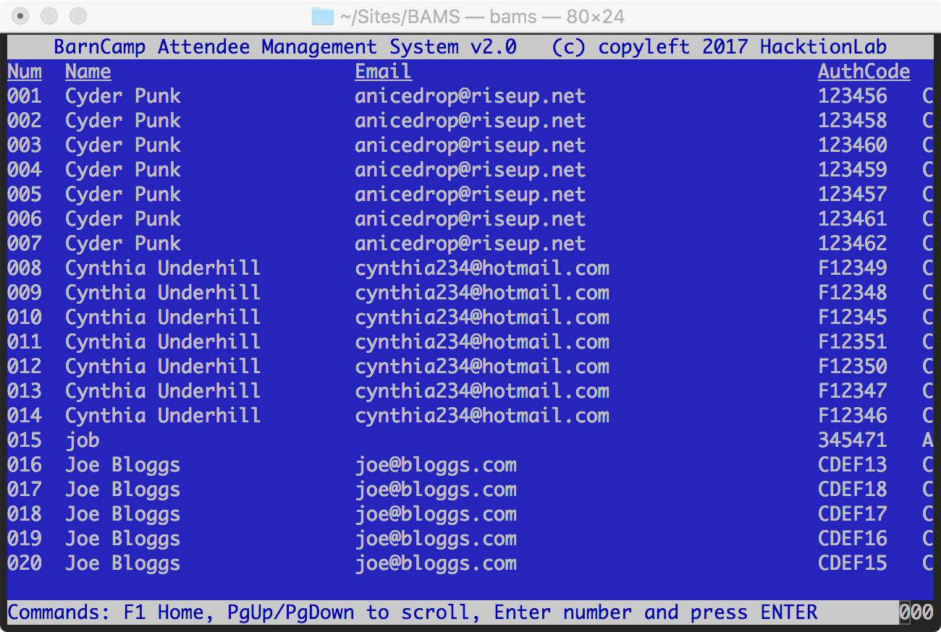](https://github.com/thebrentc/BAMS/blob/master/screenshots/list-attendees-screen.png)

[Use the PgUp and PgDn (page up and page down) keys on your keyboard to scroll through the list a page at a time until you find the attendee youre looking for.](https://github.com/thebrentc/BAMS/blob/master/screenshots/list-attendees-screen.png)

When you spot them, look for the number under the leftmost (Num) column and enter this using the keyboard and then press ENTER; you'll be taken to the Edit Attendee Screen for that attendee. Note that although the field has three 0s, it will accept you typing one or more digits.

Press F1 to return to the BAMS Home Screen.

## **View Attendee Screen**

This screen shows the attendee's details and is only shown as a confirmation screen when an attendee record has been edited and saved: [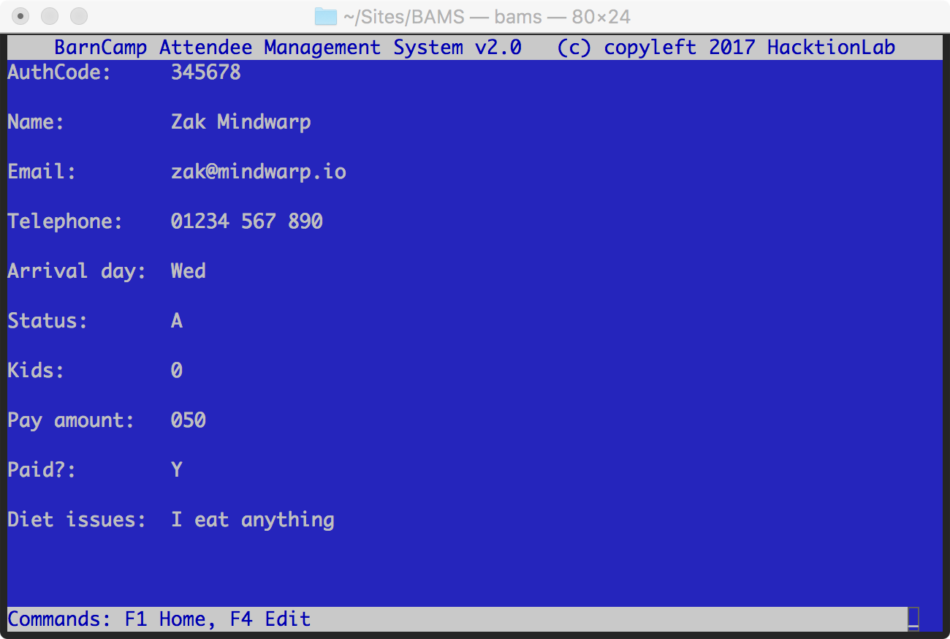](https://github.com/thebrentc/BAMS/blob/master/screenshots/view-attendee-screen.png)

[If you'd like to edit the details, press F4 to go to the Edit Attendee Screen.](https://github.com/thebrentc/BAMS/blob/master/screenshots/view-attendee-screen.png)

## **Edit Attendee Screen**

You'll arrive here from the List Attendees Screen or Search Screen, and you'll see something like this: [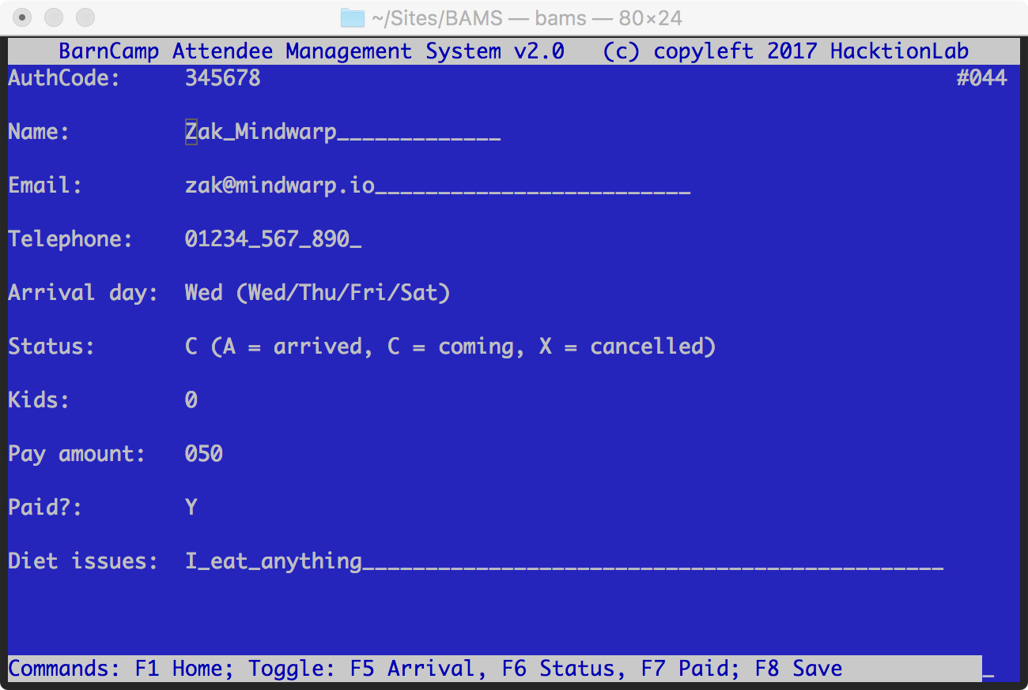](https://github.com/thebrentc/BAMS/blob/master/screenshots/edit-attendee-screen.png)

[You can edit most of the data pertaining to the attendee by navigating the fields with the cursor keys. Lef and right work in a field, and up and down will move you between fields. Note that typing wherever the cursor is will OVERWRITE the character under the cursor. So for example, to change Zak to Zek, move the cursor to the 'a' and type 'e'.](https://github.com/thebrentc/BAMS/blob/master/screenshots/edit-attendee-screen.png)

There are three fields that have special function keys used to edit them. These are:

* Arrival day - use the F5 key to toggle between Wednesday, Thursday, Friday and Saturday.
* (Arrival) Status - use the F6 key to toggle between C for coming, A for arrived, or X for Cancelled.
* Payment Status - use the F7 key to toggle between Y for yes, or N for no.

Please complete as much of the data as possible before pressing the F8 key to save. On hitting F8, you'll be taken to the View Attendee Screen. If you don't save, any changes you make will be lost.

Other function key options work as they do on the other screens.

## **Add Attendee Screen**

This is effecitvely the same screen as the Edit Screen, but a new attendee is created with a unique AuthCode. See the screenshot below, but otherwise read the Edit Attendee Section for details of how to use it.

Note: if you do not Save the new attendee any data you've entered will be lost!

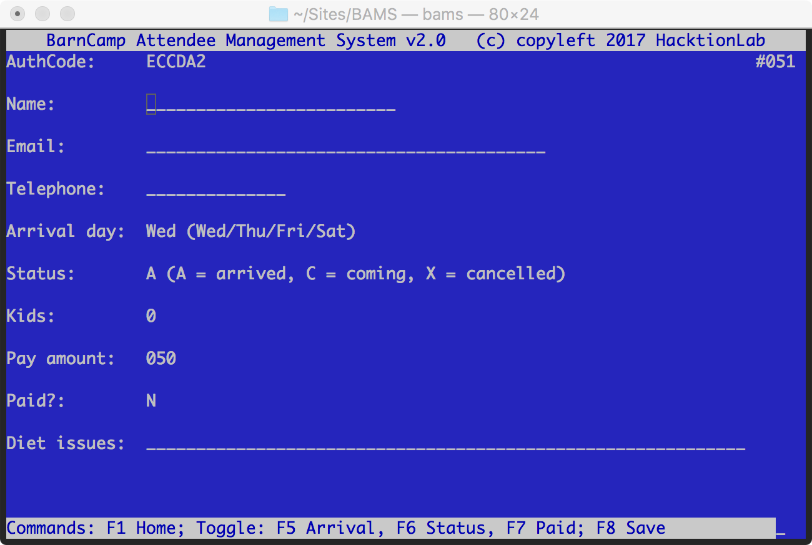

# **Operations FAQ**

Here's a list of what to do in certain situations.

## **Someone arrives and says they have booked**

* Welcome them.
* From the Home Screen go to the Search Screen by pressing F4.
* Search for them using their AuthCode, Name or Email, using F5, F6 or F7 respectively.
* If they are a new arrival their arrival status should be C. If they paid in advance, their payment status (Paid?) will be Y.
* Press the F5 key until their Arrival Day matches today.
* Press the F6 key until their Status is A.
* If they are to pay on site, because they didn't pay in advance, press the F7 key to toggle Paid? to read Y. Then edit the Pay amount field to be the amount they paid.
* Make any other changes necessary and hit F8 to save.

## **Someone arrives but hasn't booked**

* Slap them, gently.
* Welcome them.
* From the Home Screen go to the Add Screen by pressing F3.
* Press the F5 key until their Arrival Day matches today.
* Press the F6 key until their Status is A.
* Press the F7 key to toggle Paid? to read Y.
* Then edit the Pay amount field to be the amount they paid.
* Add any other details required and hit F8 to save.

## **Someone phones up and says they've cancelled**

* Comiserate with them.
* From the Home Screen go to the Search Screen by pressing F4.
* Search for them using their AuthCode, Name or Email, using F5, F6 or F7 respectively.
* Their arrival status should be C. If they paid in advance, their payment status (Paid?) will be Y.
* Press the F6 key until their Status is X.
* If they have already paid, say that they will get the many back, but a week or so after BarnCamp is over.
* Hit F8 to save.

## **Someone phones up and says they are turning up on a different day to what they thought**

* From the Home Screen go to the Search Screen by pressing F4.
* Search for them using their AuthCode, Name or Email, using F5, F6 or F7 respectively.
* Their arrival status should be C.
* Press the F5 key until their Arrival Day matches the new day they think they will arrive on.
* Make any other changes necessary and hit F8 to save.

Copyleft (2017) Hacktionlab